**HR ANALYTICS QUERIES**

* See all the data imported:

SELECT *FROM HR_Analytics

**DATA CLEANING**:

1. **REMOVE UNNECESSARY COLUMN**:

Removing unnecessary columns such as **YearsWithCurrManager, StockOptionLevel, and RelationshipSatisfaction** helps improve data quality and efficiency in analysis. These fields may contain less relevant, or unused information that does not contribute to the objectives of the HR analytics study.

ALTER TABLE HR_Analytics

DROP COLUMN YearsWithCurrManager, StockOptionLevel, RelationshipSatisfaction;

1. **CHECK DUPLICATE DATA IN COLUMN:**

Checking for duplicate values in the **EmpID** column is essential to maintain data integrity and accuracy. Since EmpID represents a unique identifier for each employee, any duplicate entries may indicate data entry errors in the dataset.

SELECT EmpID, COUNT (*) AS DuplicateCount FROM HR_Analytics

GROUP BY EmpID

HAVING COUNT (*) > 1;

1. **REMOVE DUPLICATES IN COLUMNS:**

WITH CTE AS (

SELECT *,

ROW_NUMBER () OVER (PARTITION BY EmpID ORDER BY EmpID) AS row_num

FROM HR_Analytics

)

DELETE FROM CTE WHERE row_num > 1;

1. **UPDATE INCONSISTENT VALUES IN BUSINESSTRAVEL COLUMN:**

Updating inconsistent values in the **BusinessTravel** column ensures consistency and prevents duplicate categories. Standardizing entries like “TravelRarely” to “Travel_Rarely” improves data quality, making reporting and analysis more accurate.

UPDATE HR_Analytics

SET BusinessTravel = 'Travel_Rarely'

WHERE BusinessTravel IN ('TravelRarely');

1. **UPDATE OVER18 COLUMN:**

Updating the **Over18** column ensures consistent values by replacing “Y” with “Yes”. This standardization improves clarity and avoids confusion in reporting or filtering.

UPDATE HR_Analytics

SET Over18 = 'Yes'

WHERE Over18 = 'Y';

**QUERY PROBLEMS:**

1. **Total Employees**

SELECT COUNT (EmpID) AS Total_Employees

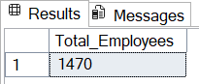FROM HR_Analytics;

1. **Avg Age of Employees**

SELECT ROUND (AVG (CAST (Age AS FLOAT)), 0) AS Avg_Age

FROM HR_Analytics;

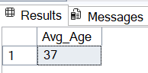

1. **Avg Year of Employees at Company**.

SELECT AVG(YearsAtCompany) AS Avg_Years_At_Company

FROM HR_Analytics;



1. **Overall Attrition Employees Count**

SELECT Attrition, COUNT (*) AS EmployeeCount

FROM HR_Analytics

GROUP BY Attrition;

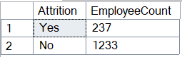

1. **Avg Salary of Employees**

SELECT (CONCAT (AVG (MonthlyIncome),' K')) AS Avg_Salary

FROM HR_Analytics;



1. **Overall Attrition Rate**

SELECT

CAST (

(SUM (CASE WHEN Attrition = 'Yes' THEN 1 ELSE 0 END) * 100.0) / COUNT (*) AS decimal (5, 2)) AS Attrition_Rate

FROM HR_Analytics;



1. **Attrition by Department**

SELECT Department, COUNT (*) AS Employee_Left

FROM HR_Analytics

WHERE Attrition ='Yes'

GROUP BY Department

ORDER BY Employee_Left desc;

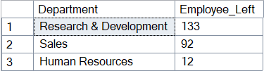

1. **Attrition by Gender (Left and Stayed)**

SELECT Gender, Attrition, COUNT (*) AS Employee Count

FROM HR_Analytics

GROUP BY Gender, Attrition;

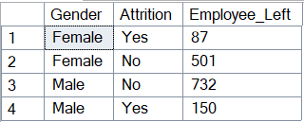

1. **Attrition Percentage by Department**

SELECT

Department,

CAST (SUM (CASE WHEN Attrition = 'Yes' THEN 1 ELSE 0 END) * 100.0 / COUNT (*) AS DECIMAL (5, 2)) AS Attrition_Percentage

FROM HR_Analytics

GROUP BY Department

ORDER BY Attrition_Percentage DESC;

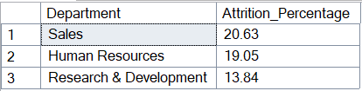

1. **Attrition by Job Role**

SELECT JobRole, COUNT (*) AS Employees_Left

FROM HR_Analytics

WHERE Attrition = 'Yes'

GROUP BY JobRole

ORDER BY Employees_Left DESC;

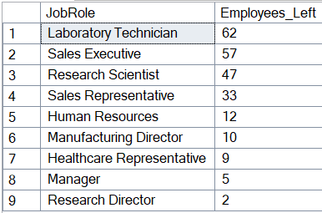

1. **Total Employees by Departments**

SELECT

Department,

COUNT (*) AS Total_Employees

FROM HR_Analytics

GROUP BY Department

ORDER BY Total_Employees DESC;

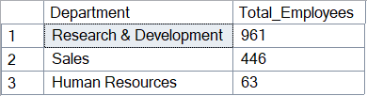

1. **Total Employees by Job Role**

SELECT

JobRole,

COUNT (*) AS Total_Employees

FROM HR_Analytics

GROUP BY JobRole

ORDER BY Total_Employees DESC;

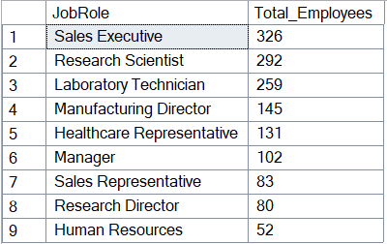

1. **Attrition by Age Group**

SELECT AgeGroup, COUNT (*) AS Employees_Left

FROM HR_Analytics

WHERE Attrition = 'Yes'

GROUP BY AgeGroup

ORDER BY Employees_Left DESC;

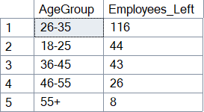

1. **Attrition by Salary Slab.**

SELECT SalarySlab, COUNT (*) AS Employees_Left

FROM HR_Analytics

WHERE Attrition = 'Yes'

GROUP BY SalarySlab

ORDER BY Employees_Left DESC;

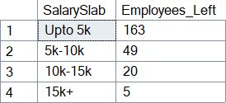

1. **Attrition by Gender**

SELECT Gender, COUNT (*) AS Employees_Left

FROM HR_Analytics

WHERE Attrition = 'Yes'

GROUP BY Gender

ORDER BY Employees_Left DESC;

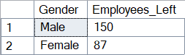

1. **Attrition by Marital Status(Left and Stayed)**

SELECT MaritalStatus, Attrition, COUNT (*) As Employee_Count

FROM HR_Analytics

GROUP BY MaritalStatus, Attrition

ORDER BY MaritalStatus, Attrition;

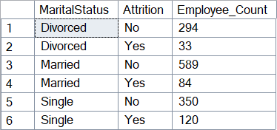

1. **Average Salary by Job Role**

SELECT JobRole, AVG (MonthlyIncome) AS Avg_Salary

FROM HR_Analytics

GROUP BY JobRole

ORDER BY Avg_Salary DESC;

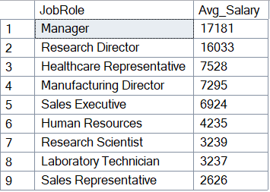

1. **Attrition by Years at Company**

SELECT YearsAtCompany, COUNT (*) AS Employees_Left

FROM HR_Analytics

WHERE Attrition = 'Yes'

GROUP BY YearsAtCompany

ORDER BY YearsAtCompany;

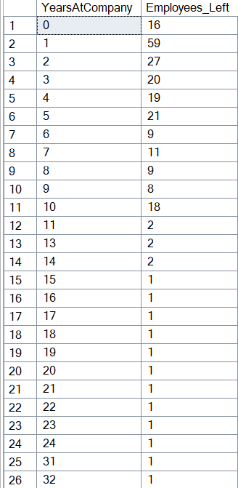



1. **Performance Rating vs Attrition**

SELECT PerformanceRating, COUNT (*) AS Employees_Left

FROM HR_Analytics

WHERE Attrition = 'Yes'

GROUP BY PerformanceRating;

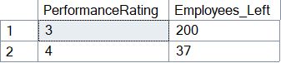

1. **Attrition by Business Travel**

SELECT BusinessTravel, COUNT (*) AS Employees_Left

FROM HR_Analytics

WHERE Attrition = 'Yes'

GROUP BY BusinessTravel

ORDER BY Employees_Left DESC;

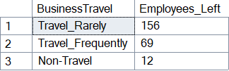

1. **Attrition by Overtime**

SELECT OverTime, COUNT (*) AS Employees_Left

FROM HR_Analytics

WHERE Attrition = 'Yes'

GROUP BY OverTime;

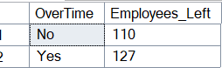

1. **Average Years in Current Role by Job Role**

SELECT JobRole, AVG (YearsInCurrentRole) AS Avg_YearsInRole

FROM HR_Analytics

GROUP BY JobRole;

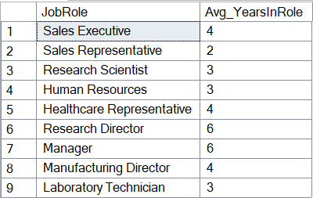

1. **Attrition by Years Since Last Promotion**

SELECT YearsSinceLastPromotion, COUNT (*) AS Employee_Left

FROM HR_Analytics

WHERE Attrition = 'Yes'

GROUP BY YearsSinceLastPromotion

ORDER BY YearsSinceLastPromotion;

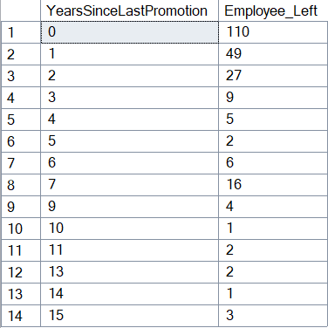

1. **Job Satisfaction by Job Role**

SELECT JobRole, AVG (JobSatisfaction) AS Avg_JobSatisfaction

FROM HR_Analytics

GROUP BY JobRole

ORDER BY Avg_JobSatisfaction DESC;

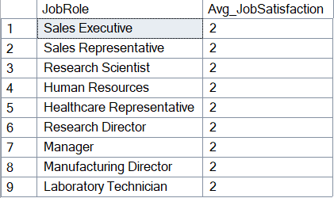

1. **Attrition by Work-Life Balance Rating**

SELECT WorkLifeBalance, COUNT (*) AS Employees_Left

FROM HR_Analytics

WHERE Attrition = 'Yes'

GROUP BY WorkLifeBalance

ORDER BY WorkLifeBalance;

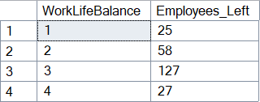

*******END*******